**Het balansmodel**

[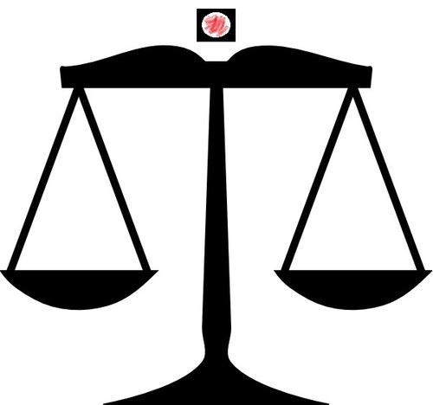](https://www.google.nl/url?sa=i&rct=j&q=&esrc=s&frm=1&source=images&cd=&cad=rja&uact=8&ved=0ahUKEwjXmZr9zJfKAhXDJA8KHcEGDysQjRwIBw&url=https://twitter.com/stemmen_tk12&psig=AFQjCNGi84SlQpPsNRvNfiP-qce8mAwlVA&ust=1452252672179258)